**Interval Rank [pairwise & listwise]**

Recent work on ranking focused on a number of different paradigms such as pointwise, pairwise, and list-wise approaches. Each of those paradigms focuses on a different aspect of the dataset while largely ignoring others. Interval rank shows how a combination of them can lead to improved ranking performance and also, how it can be implemented in log-linear time.

The basic idea of the algorithm is to use isotonic regression with adaptive bandwidth selection per relevance grade

Disadvantage of listwise:

* Ignore some parts that the pairwise or pointwise can capture

Disadvantage of pairwise:

* They ignore that a document with a mediocre rating may actually be desirable if all other documents carry even lower score

The method:

1. Isotonic Regression to deal with the listwise, translation
2. Adding penalty to equally rate documents with the same grade
3. Impose large margin constraints between the grades to make sure that ratings are obtained in a reliable fashion

The loss function is defined *implicitly* as the solution of a convex optimization problem.

**The Ranking SVM**

The goal is to classify instance pairs as correctly ranked or incorrectly ranked which eventually means 1/0 – binary classification problem.

The method:

1. Define the problem equation: yu > yv iff w*(xu − xv) > 0
2. Create a new instance space from such pairs:

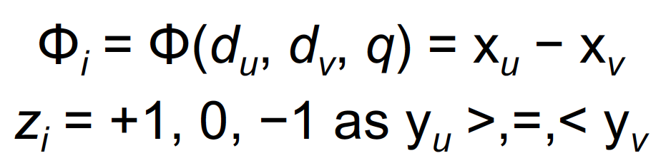

1. Build a model over the cases where zi = -1
2. Train SVM on the training data S = {Φi}

Since SVM is a pairwise method, it could ignore a document with a mediocre rating. On the other hand, the relations between relevance levels are modelled.

**References**

-Cao, Y., Xu, J. Liu, T.-Y., Li, H., Huang, Y. and Hon, H.-W. Adapting Ranking SVM to Document Retrieval, SIGIR 2006.

-Taesup Moon, Alex Smola, Yi Chang and Zhaohui Zheng, IntervalRank — Isotonic Regression

with Listwise and Pairwise Constraints